**Podcast Plus**

**A Redux-Inspired Podcast App with Dynamic Themes**

**1. INTRODUCTION**

**1.1.Objective of the Project**

With the rise in podcast consumption globally, users seek a streamlined and engaging podcast experience. The "Podcast Plus" app is designed to cater to modern listeners, combining a clean, dynamic UI with powerful playback features. The project focuses on delivering intuitive controls, easy access to podcast collections, and a personalized theme experience.

**1.2.Key Features:**

* **User Authentication**: Secure login and registration for personalized use.
* **Browse and Search**: Easily discover podcasts by browsing categories or using the search function.
* **Playback Controls**: Play, pause, resume, and seek within podcasts.
* **Dynamic Themes**: Customizable themes for personalized user experiences.
* **Favorites**: Save and access frequently played podcasts.

**1.3.Project Goals:**

* Build an intuitive and aesthetically pleasing podcast app using **Jetpack Compose**.
* Integrate **ExoPlayer** for robust media playback.
* Incorporate centralized state management to ensure smooth app performance.
* Optimize the app for Android devices running version 8.0 (Oreo) or later.

**2. LITERATURE SURVEY**

**2.1. Existing Problems**

While there are several podcast applications available, most suffer from the following limitations:

* **Complex Interfaces**: Overloaded with features, making navigation cumbersome.
* **Limited Personalization**: Lack of flexibility in adapting themes and layouts to user preferences.
* **Inconsistent Performance**: Issues with playback reliability, especially during multitasking or background usage.

**2.2. Proposed Solution**

"Podcast Plus" addresses these challenges by introducing:

* **Simplified Navigation**: A clean, Compose-based UI to ensure ease of use.
* **Dynamic Themes**: Customizable themes that enhance user engagement and accessibility.
* **Reliable Playback**: Integrated ExoPlayer for a smooth and uninterrupted listening experience.
* **Optimized Architecture**: A Redux-inspired state management system to ensure scalability and maintainability.

**3. SYSTEM DESIGN AND REQUIREMENTS**

**3.1. Architectural Design**

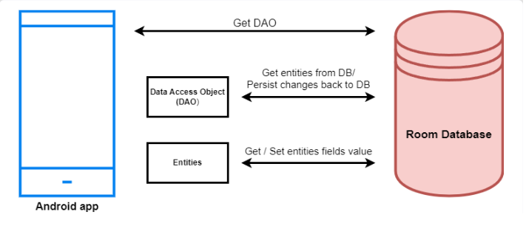

**3.1.1.Key components**

* **Authentication Module**: Manages secure user registration and login.
* **Playback Module**: Uses ExoPlayer for audio playback.
* **Database Module**: SQLite or Room Database for storing user and podcast data.
* **UI Module**: Built with Jetpack Compose for modern, declarative UI development.

**3.2.Workflow Description:**

* **Authentication**: Users register or log in to access the app.
* **Podcast Selection**: The main page lists available podcasts, fetched via APIs or a local database.
* **Playback**: Users can play, pause, resume, or seek within a podcast.
* **Theme Customization**: Dynamic themes adapt to user preferences or system settings.

**3.3.Hardware Requirements**

**Development Environment:**

* **Processor**: Intel Core i5/i7 or equivalent.
* **RAM**: Minimum 8 GB (16 GB recommended).
* **Storage**: SSD (minimum 512 GB).
* **Display**: Full HD (1920x1080) resolution or higher.
* **Smartphone**: Android device (version 8.0 or newer) for testing.

**End-User Device:**

* **Operating System**: Android 8.0 or newer.
* **RAM**: Minimum 2 GB (4 GB recommended).
* **Storage**: 50 MB free for app installation and user data.
* **Connectivity**: Wi-Fi or mobile data for streaming podcasts.

**3.3. Software Requirements**

**Development Environment:**

* **Programming Language**: Kotlin.
* **IDE**: Android Studio Arctic Fox or newer.
* **Libraries**: Jetpack Compose, Retrofit, Room, ExoPlayer.
* **Version Control**: Git for collaboration and versioning.

**End-User Environment:**

* **Distribution Platform**: Google Play Store.
* **Permissions**: Internet, storage, and notifications.

**4. PROJECT WORKFLOW**

**4.1. Functional Overview**

**• Authentication:**

* New users register by providing personal details.
* Existing users log in with secure credentials.

**• Main Page:**

* Display podcasts categorized by genres.
* Allow searching for specific podcasts.

**• Playback Features:**

* Users can play, pause, and resume podcasts.
* Seek functionality enables skipping forward or backward.

**• Dynamic Themes:**

* Users can customize themes from settings.

**• Favorites:**

* Users can save favorite podcasts for quick access.

**5.FLOWCHART**

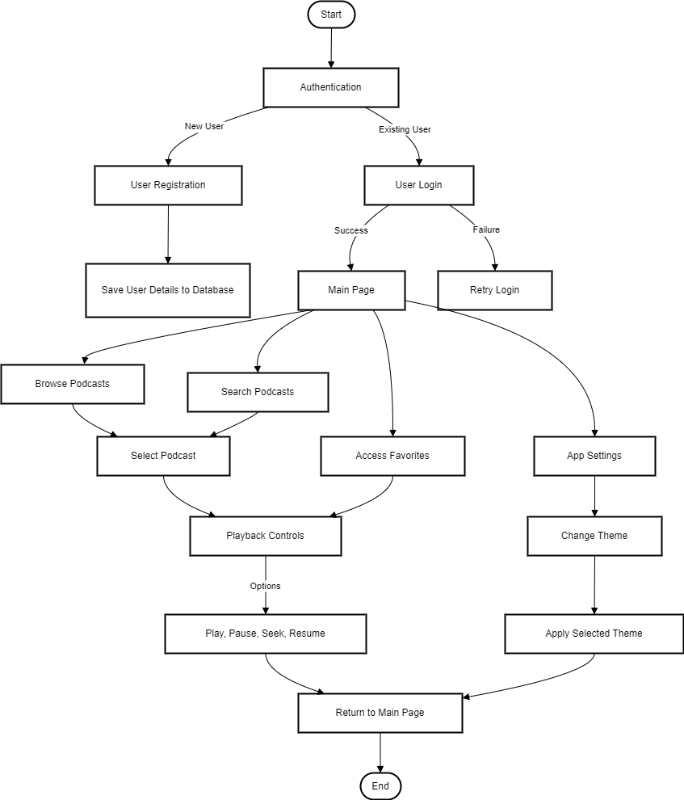

**6.Program**

**MainActivity.kt**

package com.example.podcastplayer

import android.content.Context

import android.media.MediaPlayer

import android.os.Bundle

import androidx.activity.ComponentActivity

import androidx.activity.compose.setContent

import androidx.compose.foundation.BorderStroke

import androidx.compose.foundation.Image

import androidx.compose.foundation.layout.*

import androidx.compose.foundation.rememberScrollState

import androidx.compose.foundation.verticalScroll

import androidx.compose.material.*

import androidx.compose.runtime.*

import androidx.compose.ui.Alignment

import androidx.compose.ui.Modifier

import androidx.compose.ui.graphics.Color

import androidx.compose.ui.res.painterResource

import androidx.compose.ui.text.font.FontWeight

import androidx.compose.ui.text.style.TextAlign

import androidx.compose.ui.unit.dp

import androidx.compose.ui.unit.em

import androidx.compose.ui.unit.sp

import com.example.podcastplayer.ui.theme.PodcastPlayerTheme

class MainActivity : ComponentActivity() {

override fun onCreate(savedInstanceState: Bundle?) {

super.onCreate(savedInstanceState)

setContent {

PodcastPlayerTheme {

// A surface container using the 'background' color from the theme

Surface(

modifier = Modifier.fillMaxSize(),

color = MaterialTheme.colors.background

) {

playAudio(this)

}

}

}

}

}

@Composable

fun playAudio(context: Context) {

Column(modifier = Modifier.fillMaxSize()) {

Column(horizontalAlignment = Alignment.CenterHorizontally, verticalArrangement = Arrangement.Center) {

Text(text = "PODCAST",

modifier = Modifier.fillMaxWidth(),

textAlign = TextAlign.Center,

color = Color(0xFF6a3ef9),

fontWeight = FontWeight.Bold,

fontSize = 36.sp,

style = MaterialTheme.typography.h1,

letterSpacing = 0.1.em

)

}

Column(modifier = Modifier

.fillMaxSize()

.verticalScroll(rememberScrollState())) {

Card(

elevation = 12.dp,

border = BorderStroke(1.dp, Color.Magenta),

modifier = Modifier

.padding(16.dp)

.fillMaxWidth()

.height(250.dp)

)

{

val mp: MediaPlayer = MediaPlayer.create(context, R.raw.audio)

Column(

modifier = Modifier.fillMaxSize(),

horizontalAlignment = Alignment.CenterHorizontally

) {

Image(

painter = painterResource(id = R.drawable.img),

contentDescription = null,

modifier = Modifier

.height(150.dp)

.width(200.dp),

)

Text(

text = "GaurGopalDas Returns To TRS - Life, Monkhood & Spirituality",

textAlign = TextAlign.Center,

modifier = Modifier.padding(start = 20.dp, end = 20.dp)

)

Row() {

IconButton(onClick = { mp.start() }, modifier = Modifier.size(35.dp)) {

Icon(

painter = painterResource(id = R.drawable.play),

contentDescription = ""

)

}

IconButton(onClick = { mp.pause() }, modifier = Modifier.size(35.dp)) {

Icon(

painter = painterResource(id = R.drawable.pause),

contentDescription = ""

)

}

}

}

}

Card(

elevation = 12.dp,

border = BorderStroke(1.dp, Color.Magenta),

modifier = Modifier

.padding(16.dp)

.fillMaxWidth()

.height(250.dp)

)

{

val mp: MediaPlayer = MediaPlayer.create(context, R.raw.audio_1)

Column(

modifier = Modifier.fillMaxSize(),

horizontalAlignment = Alignment.CenterHorizontally

) {

Image(

painter = painterResource(id = R.drawable.img_1),

contentDescription = null,

modifier = Modifier

.height(150.dp)

.width(200.dp)

)

Text(

text = "Haunted Houses, Evil Spirits & The Paranormal Explained | Sarbajeet Mohanty",

textAlign = TextAlign.Center,

modifier = Modifier.padding(start = 20.dp, end = 20.dp)

)

Row() {

IconButton(onClick = { mp.start() }, modifier = Modifier.size(35.dp)) {

Icon(

painter = painterResource(id = R.drawable.play),

contentDescription = ""

)

}

IconButton(onClick = { mp.pause() }, modifier = Modifier.size(35.dp)) {

Icon(

painter = painterResource(id = R.drawable.pause),

contentDescription = ""

)

}

}

}

}

Card(

elevation = 12.dp,

border = BorderStroke(1.dp, Color.Magenta),

modifier = Modifier

.padding(16.dp)

.fillMaxWidth()

.height(250.dp)

)

{

val mp: MediaPlayer = MediaPlayer.create(context, R.raw.audio_2)

Column(

modifier = Modifier.fillMaxSize(),

horizontalAlignment = Alignment.CenterHorizontally

) {

Image(

painter = painterResource(id = R.drawable.img_2),

contentDescription = null,

modifier = Modifier

.height(150.dp)

.width(200.dp)

)

Text(

text = "Kaali Mata ki kahani - Black Magic & Aghoris ft. Dr Vineet Aggarwal",

textAlign = TextAlign.Center,

modifier = Modifier.padding(start = 20.dp, end = 20.dp)

)

Row() {

IconButton(onClick = { mp.start() }, modifier = Modifier.size(35.dp)) {

Icon(

painter = painterResource(id = R.drawable.play),

contentDescription = ""

)

}

IconButton(onClick = { mp.pause() }, modifier = Modifier.size(35.dp)) {

Icon(

painter = painterResource(id = R.drawable.pause),

contentDescription = ""

)

}

}

}

}

Card(

elevation = 12.dp,

border = BorderStroke(1.dp, Color.Magenta),

modifier = Modifier

.padding(16.dp)

.fillMaxWidth()

.height(250.dp)

)

{

val mp: MediaPlayer = MediaPlayer.create(context, R.raw.audio_3)

Column(

modifier = Modifier.fillMaxSize(),

horizontalAlignment = Alignment.CenterHorizontally

) {

Image(

painter = painterResource(id = R.drawable.img_3),

contentDescription = null,

modifier = Modifier

.height(150.dp)

.width(200.dp),

)

Text(

text = "Tantra Explained Simply | Rajarshi Nandy - Mata, Bhairav & Kamakhya Devi",

textAlign = TextAlign.Center,

modifier = Modifier.padding(start = 20.dp, end = 20.dp)

)

Row() {

IconButton(onClick = { mp.start() }, modifier = Modifier.size(35.dp)) {

Icon(

painter = painterResource(id = R.drawable.play),

contentDescription = ""

)

}

IconButton(onClick = { mp.pause() }, modifier = Modifier.size(35.dp)) {

Icon(

painter = painterResource(id = R.drawable.pause),

contentDescription = ""

)

}

}

}

}

Card(

elevation = 12.dp,

border = BorderStroke(1.dp, Color.Magenta),

modifier = Modifier

.padding(16.dp)

.fillMaxWidth()

.height(250.dp)

)

{

val mp: MediaPlayer = MediaPlayer.create(context, R.raw.audio_4)

Column(

modifier = Modifier.fillMaxSize(),

horizontalAlignment = Alignment.CenterHorizontally

) {

Image(

painter = painterResource(id = R.drawable.img_4),

contentDescription = null,

modifier = Modifier

.height(150.dp)

.width(200.dp),

)

Text(

text = "Complete Story Of Shri Krishna - Explained In 20 Minutes",

textAlign = TextAlign.Center,

modifier = Modifier.padding(start = 20.dp, end = 20.dp)

)

Row() {

IconButton(onClick = { mp.start() }, modifier = Modifier.size(35.dp)) {

Icon(

painter = painterResource(id = R.drawable.play),

contentDescription = ""

)

}

IconButton(onClick = { mp.pause() }, modifier = Modifier.size(35.dp)) {

Icon(

painter = painterResource(id = R.drawable.pause),

contentDescription = ""

)

}

}

}

}

Card(

elevation = 12.dp,

border = BorderStroke(1.dp, Color.Magenta),

modifier = Modifier

.padding(16.dp)

.fillMaxWidth()

.height(250.dp)

)

{

val mp: MediaPlayer = MediaPlayer.create(context, R.raw.audio_5)

Column(

modifier = Modifier.fillMaxSize(),

horizontalAlignment = Alignment.CenterHorizontally

) {

Image(

painter = painterResource(id = R.drawable.img_5),

contentDescription = null,

modifier = Modifier

.height(150.dp)

.width(200.dp),

)

Text(

text = "Mahabharat Ki Poori Kahaani - Arjun, Shri Krishna & Yuddh - Ami Ganatra ",

textAlign = TextAlign.Center,

modifier = Modifier.padding(start = 20.dp, end = 20.dp)

)

Row() {

IconButton(onClick = { mp.start() }, modifier = Modifier.size(35.dp)) {

Icon(

painter = painterResource(id = R.drawable.play),

contentDescription = ""

)

}

IconButton(onClick = { mp.pause() }, modifier = Modifier.size(35.dp)) {

Icon(

painter = painterResource(id = R.drawable.pause),

contentDescription = ""

)

}

}

}

} } }

**7. RESULTS**

The *Podcast Plus* app has successfully demonstrated:

* A modern, responsive UI using Jetpack Compose.
* Robust audio playback powered by ExoPlayer.
* Dynamic themes for an engaging user experience.

**8. ADVANTAGES AND DISADVANTAGES**

**8.1. Advantages**

* **User-Friendly**: The Compose-based UI simplifies navigation and enhances user experience.
* **Dynamic Design**: Themes provide aesthetic flexibility, ensuring accessibility.
* **Efficient Performance**: Optimized state management ensures minimal resource usage.

**8.2. Disadvantages**

* **Platform Dependency**: Currently limited to Android devices.
* **Internet Reliance**: Requires an active connection for streaming content.

**9.Applications of Podcast Plus**

1. **Entertainment**:
   * Serves as a platform for users to discover and enjoy their favorite podcasts, ranging from comedy to drama.
2. **Education**:
   * Provides access to educational and informative podcasts, such as language learning, history lessons, or tech insights.
3. **Professional Development**:
   * Offers podcasts focused on career growth, industry trends, and skills development.
4. **News and Current Events**:
   * Acts as a reliable source for staying updated on daily news, politics, and global trends.
5. **Mental Health and Wellness**:
   * Features wellness and mindfulness podcasts to help users relax and unwind.
6. **Marketing and Branding for Podcasters**:
   * Allows podcasters to reach a wider audience and promote their brand effectively.
7. **Community Building**:
   * Encourages users to engage with niche communities by joining fan groups or discussion forums.
8. **Accessibility**:
   * Offers a platform for people with disabilities to access audio-based content easily.

**10.Future Scope of Podcast Plus**

1. **Cross-Platform Expansion**:
   * **iOS Support**: Expanding the app to iOS devices to capture a broader audience.
   * **Web Version**: Building a responsive web application for desktop and browser users.
2. **Offline Mode**:
   * Introducing offline downloads for podcasts to enable playback without internet connectivity.
3. **Personalized Recommendations**:
   * Utilizing **machine learning** algorithms to suggest podcasts based on user interests, history, and trends.
4. **Enhanced Playback Features**:
   * Speed control: Allow users to listen at various playback speeds.
   * Chapter markers: For easy navigation within episodes.
   * Sleep timer: Automatically stop playback after a set time.
5. **Monetization Options**:
   * Adding a subscription model for ad-free listening and exclusive content.
   * Support for in-app purchases like premium podcasts or bundles.
6. **Social Sharing and Collaboration**:
   * Features to share favorite podcasts or create playlists with friends.
   * Integration with social media platforms for better community engagement.
7. **Integration with Smart Devices**:
   * Support for smart speakers (e.g., Amazon Echo, Google Nest) and wearables.
   * Voice command support for hands-free navigation.
8. **Podcast Creator Tools**:
   * Provide features for podcasters to upload and manage their content directly within the app.
9. **Improved Analytics**:
   * Display in-depth stats like most-played episodes, listener trends, and time spent on the app.
   * Offer podcast creators insights into listener engagement.

**10.SCREENSHOTS**

**Sign up Page Login Page**

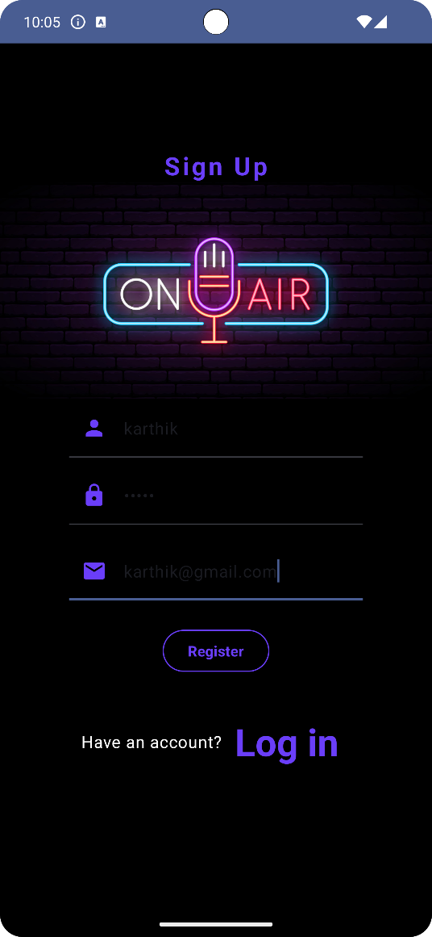 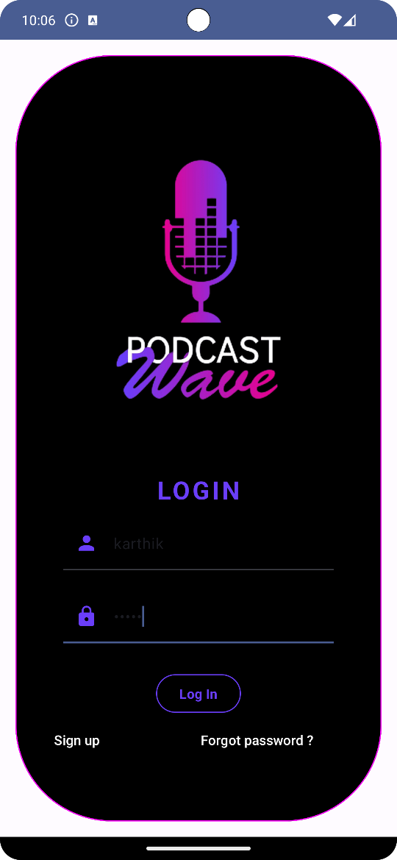

**HomePage**

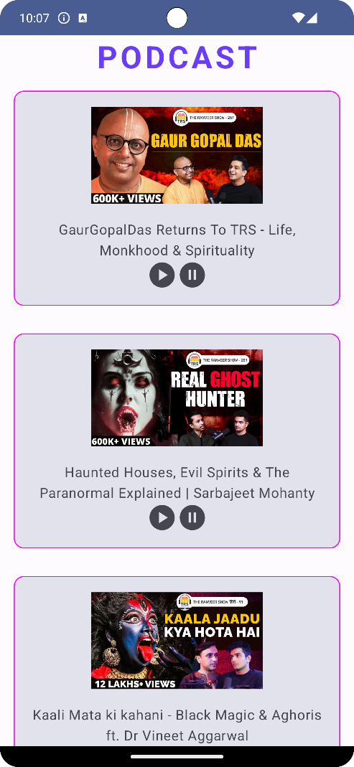

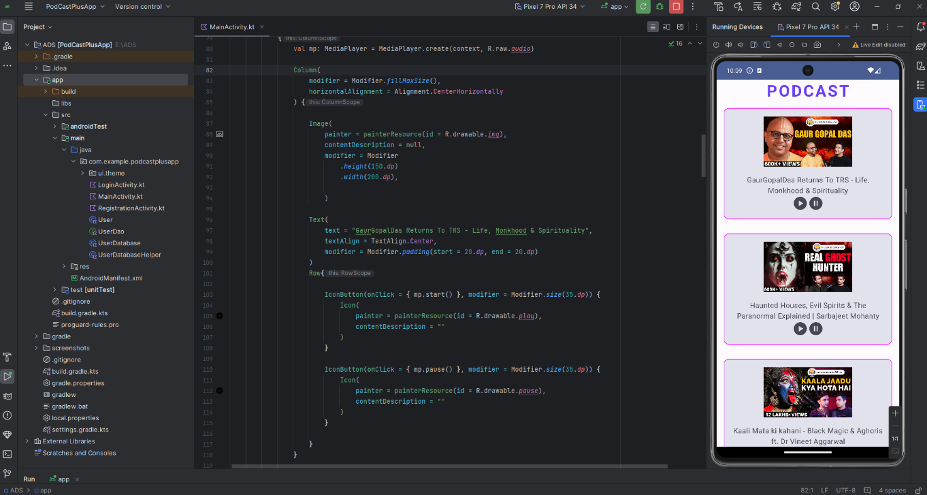

**12. CONCLUSION**

The *Podcast Plus* app is a robust and user-friendly solution for podcast enthusiasts. By leveraging the latest Android technologies such as Jetpack Compose and ExoPlayer, the app ensures an engaging and reliable user experience. Future enhancements may include:

* Offline podcast downloads.
* Cross-platform support for iOS.
* Personalized recommendations based on user preferences and history.